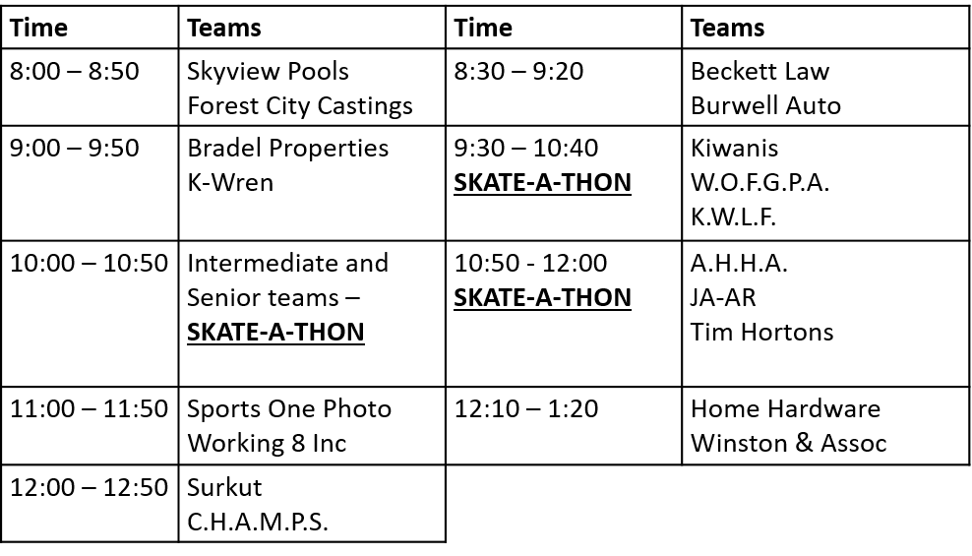

**SCHEDULE CHANGES – DECEMBER 15TH**

Please note the following schedule changes for Saturday Dec 15th

**GBSA**

We hope to see all our players out for our annual

**Skate-A-thon!**

It’s a fun day with lots of fun, skating and of course holiday cheer!