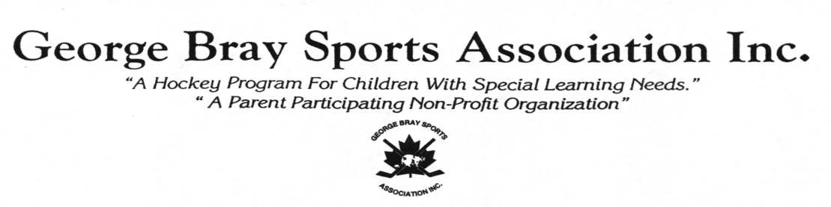
2019-2020 Hockey Season
Registration for the 2019-2020 Hockey Season and Hockey School will be taking place at

KINSMEN ARENA – 20 Granville St on the following dates:
SATURDAY SEPTEMBER 14 from 9:00 am – NOON

WEDNESDAY SEPTEMBER 18 from 6:00 pm – 9:00 pm

SATURDAY SEPTEMBER 21 from 9:00 am – NOON

WEDNESDAY SEPTEMBER 25 from 6:00 pm – 8:00 pm

NEW!

For Returning Players: the registration forms have been pre-populated and will be at the arena on registration day for you to review and confirm your information.

Remember: to bring a parent or legal guardian if the player is under the age of 18 to review the pre-populated registration and health forms. Waiver forms will be required for insurance reasons to be completed and signed by the player or a parent/legal guardian for players under 18 years of age at the time of registration.

Note: all forms must be Reviewed before a player is allowed on the ice. Please see Registrar with any concerns.
For new players: Registration information will be filled out at the arena on the day of registration.
To qualify to play in GBSA we will require at registration supporting documentation that indicates the player’s need for a modified or accommodated program such as a copy of the player’s I.E.P, I.P.R.C, or a letter from a physician, teacher/learning support teacher.
Registration Fees:
Player Registration fees for the 2019-2020 Season are: $180.00 for ALL Divisions
The registration fees include ice time, a team picture and an award at the year-end banquet.

*NEW - Please note – players going on a payment plan will be required to pay a minimum of 25% of total fee before going on the ice Sept 28. All payment plans will be paid in full by January.

All cheques or money orders are payable to “George Bray Sports Association Inc.” There will be a $20 administration charge for NSF cheques.

Players will be notified of dates and times for your Division at the time of registration. Hockey games will begin Saturday September 28.

Hockey School (registration fee = $70.00/player) will begin on Wednesday, October 2nd. Due to a limited amount of space, those who are interested in signing up are encouraged to register during the scheduled registration dates.

Equipment:

Players who need to borrow equipment must be fitted for their equipment during the scheduled registration dates. All players are required to wear full hockey equipment to participate in practices and games. Team Jersey and black socks will be provided by the league and must be worn on the ice.
Allison Browning, Registrar: a.browning2@hotmail.com
Murray Howard, President: murrayhoward@execulink.com

Save the date….. ‘Our biggest fundraiser of the year is being held on March 7, 2020. This event is successful due to donations and support by our players, families and sponsors. Keep an eye out for more information in the coming months…’

Join the GBSA Hockey School!!
You will have FUN while
Learning to Skate,
Improving your Skating, Balance, Puck Handling
and Stride

When/Where: Wednesdays from 6-7 at Kinsmen Arena
Learn to Skate and Drills/Skills Programs are on alternating Wednesdays
Start Dates: Learn to Skate & Basic Skills: Wednesday, October 2nd
Advanced Drills & Skills: Wednesday, October 9th
Cost: $70 for the season
*** As part of our Fundamentals Program;
Hockey School is included at no additional cost ***

